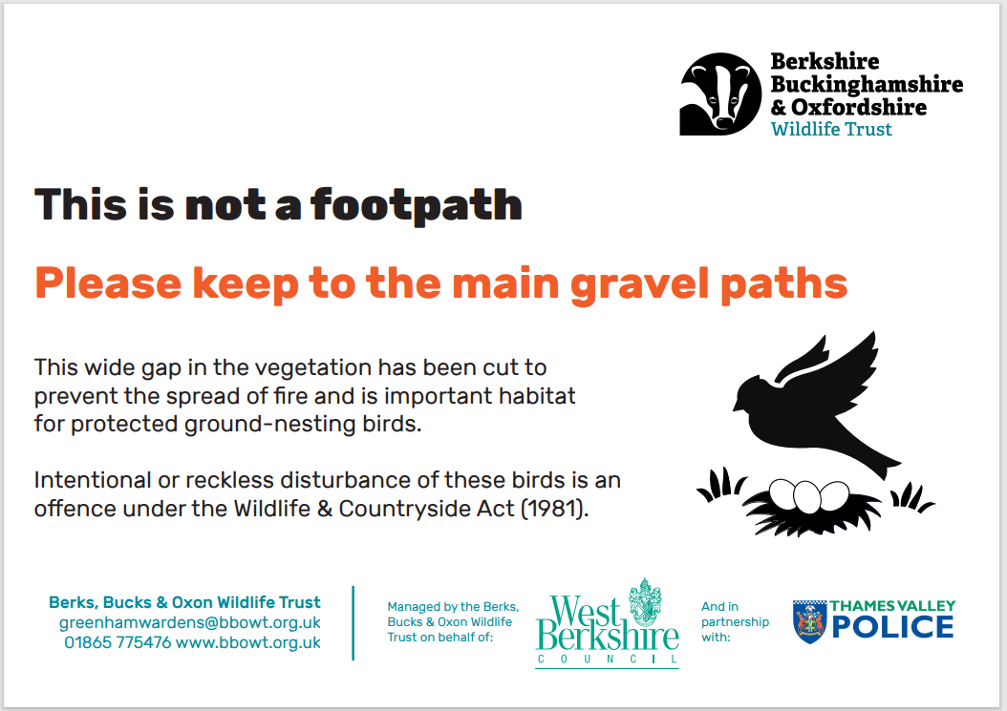

Online Survey  
  
Take part in our online visitor survey by either scanning the QR code or visiting: **https://tinyurl.com/GreenhamSurvey**